الاصطناعي
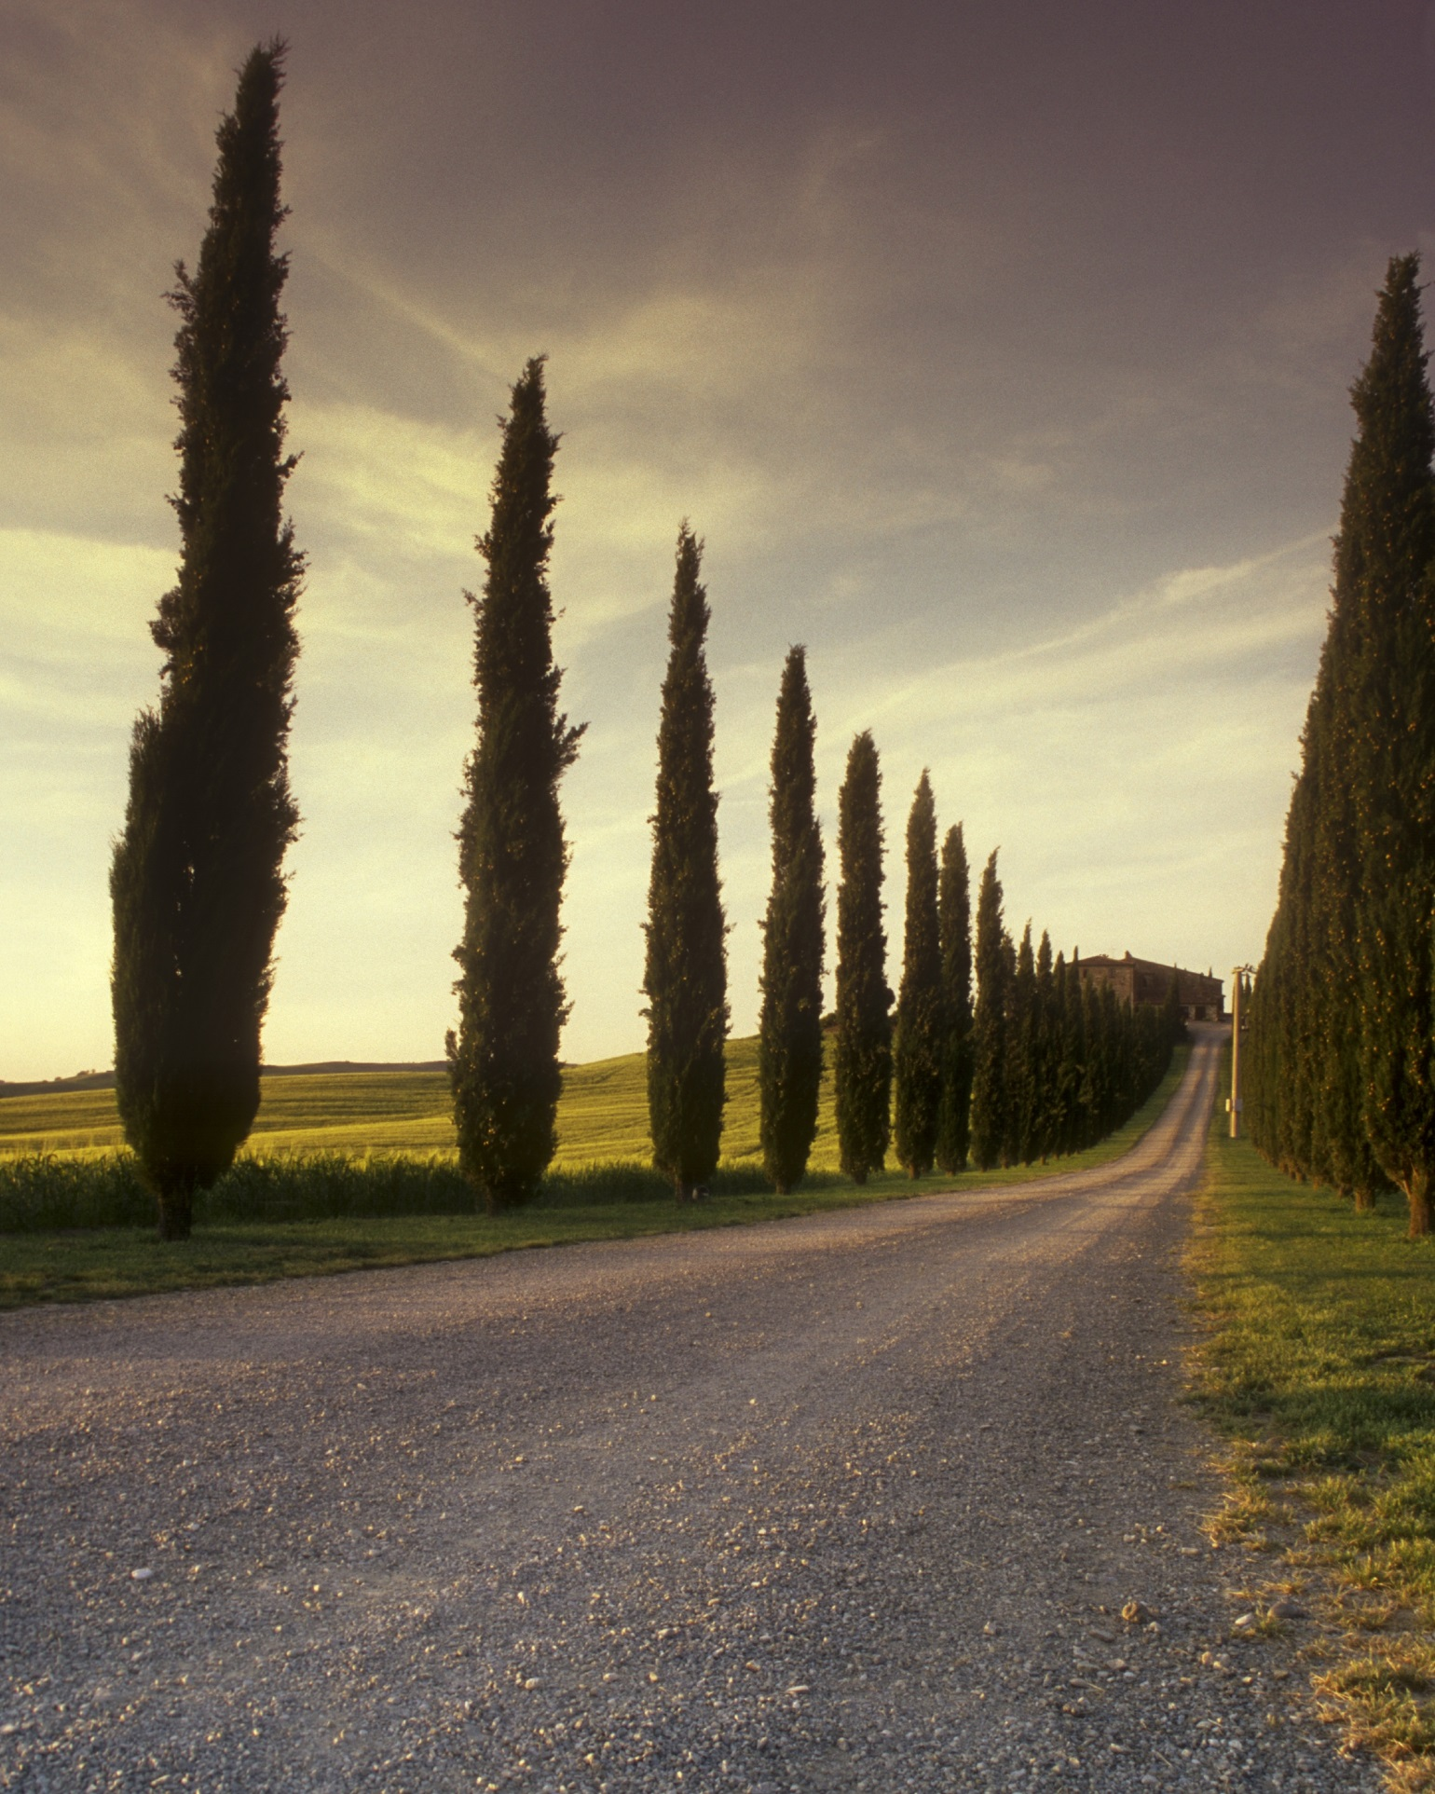  waste management by (ai) | DR .IBRAHIM MOHAMED ABDELLATIF  BY: Mohamed ahmed saleh

